No-SQL Database

NoSQL databases come in a few main types, each optimized for different kinds of data and access patterns. Here’s the clean mental map
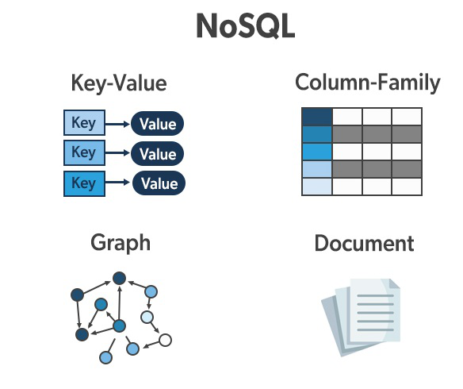

1. Key–Value Stores
- Data stored as key → value
- Super fast, very simple
- Great for caching, sessions, user preferences
Examples: Redis, DynamoDB, Riak
Think: giant hashmap

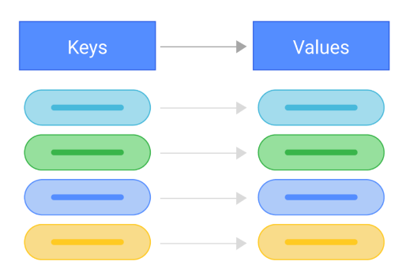

2. Document Databases
- Store data as documents (JSON/BSON/XML)
- Flexible schema (fields can vary per document)
- Easy for web & mobile apps
Examples: MongoDB, CouchDB, Firestore
Think: JSON objects in collections
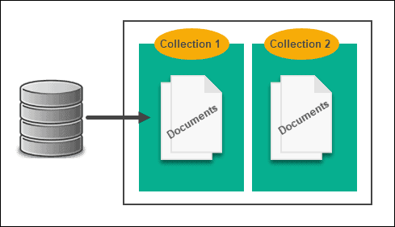 | 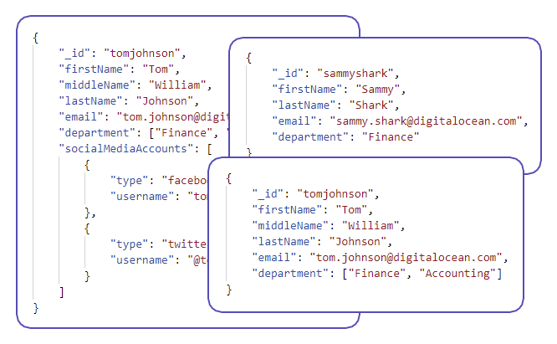

// Document A
{ "name": "Alice", "email": "alice@example.com" }

// Document B
{ "name": "Bob", "age": 32, "skills": ["Go", "SQL"] }

3. Column-Family (Wide-Column) Stores
- Data stored in rows and column families
- Optimized for large-scale analytics and writes
- Scales insanely well
Examples: Cassandra, HBase, ScyllaDB
Think: rows with dynamic columns
Row1 has 2 columns and row2 has 3 columns.
Row 1:
profile:name = “Alice”
profile:email = “alice@example.com”

Row 2:
profile:name = “Bob”
profile:age = 32
profile:skills = [“Go”, “SQL”]
- profile → column family (Row Key)
- name, email, age → column names
- Column names are often dynamic
- Different rows can have different column names
👉 Column name is defined at write time, not schema time
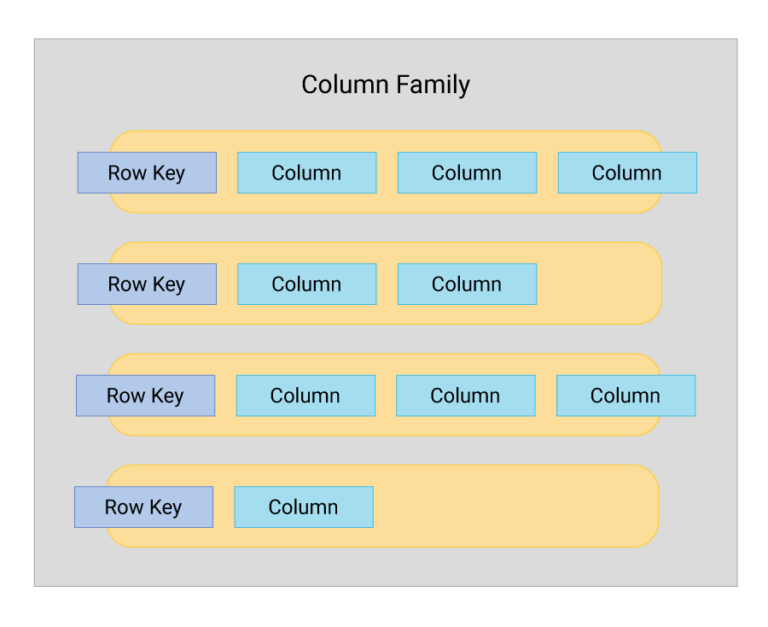

4. Graph Databases
- Data stored as nodes and edges
- Excellent for relationships and connections
Examples: Neo4j, Amazon Neptune, ArangoDB
Think: social networks, recommendations, fraud detection
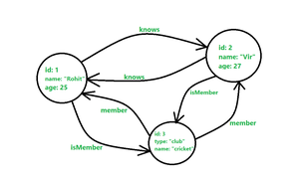

5. Time-Series Databases (often grouped under NoSQL)
- Optimized for time-stamped data
- High write throughput
Examples: InfluxDB, TimescaleDB, OpenTSDB
Think: metrics, IoT, monitoring
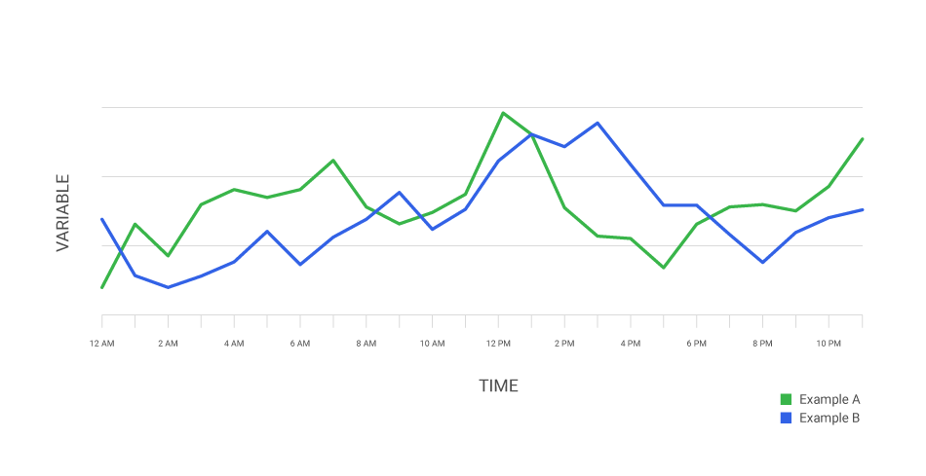

6. Search-Oriented NoSQL Databases
- Optimized for text search & analytics
- Full-text search, ranking, aggregation
Examples: Elasticsearch, Solr
Think: Google-like search over your data

7. Quick rule of thumb
- 🔑 Fast lookups → Key–Value
- 📄 Flexible app data → Document
- 📊 Big distributed data → Column-family
- 🧠 Relationships matter → Graph
- ⏱ Metrics & logs → Time-series

8. Read/Write performance
NoSQL Type | Read Performance | Write Performance | What It’s Best At
Key–Value | ⭐⭐⭐⭐⭐ (fastest) | ⭐⭐⭐⭐⭐ (fastest) | Caching, sessions
Document | ⭐⭐⭐⭐ | ⭐⭐⭐⭐ | Web & mobile apps
Column-Family | ⭐⭐⭐ | ⭐⭐⭐⭐⭐ | Massive write-heavy data
Graph | ⭐⭐⭐⭐⭐ (for relations) | ⭐⭐⭐ | Relationship queries
Time-Series | ⭐⭐⭐⭐ | ⭐⭐⭐⭐⭐ | Metrics, logs, IoT
Search / Index | ⭐⭐⭐⭐⭐(only in search read) | ⭐⭐ | Full-text search

